WORLESTON & DISTRICT PARISH COUNCIL
ANNUAL PARISH COUNCIL MEETING
To be held at Worleston Village Hall
Not to start before 7.15pm 12th May 2022
Clerk to the Parish Council: Helen Exley, Daisy Bank Farm, off Top Farm Lane, Cholmondeston, Cheshire CW7 4DR 01270 528768
E mail: clerk@worlestondistrict-pc.gov.uk

All members of the public are welcome to attend.

AGENDA

- Election of Chairman
- Election of Vice Chairman
- Election of Responsible Financial Officer
- Public Forum

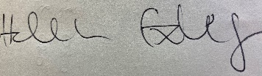

Helen Exley
Clerk - Worleston Parish Council

4th May 2022

